Chemical Kinetics (Exercise)

1. Multiple Choice Questions (MCQs)
i. The rate of a reaction ______ as the reaction proceeds.
(a) Increases
(b) Decreases
(c) Remains the same
(d) May increase or decrease.
Explanation: The rate is highest at the start because the concentration of reactants is highest. As reactants are consumed, their concentration decreases, leading to fewer collisions and a slower rate.
ii. The activation energy for a reaction can be:
(a) Increased by increasing temperature
(b) Increased by decreasing temperature
(c) Decreased by increasing concentration of reactants
(d) None of these
Explanation: Activation energy is an intrinsic energy barrier for a specific reaction pathway. It cannot be changed by altering temperature or concentration; these factors only change the energy of the particles or their frequency of collision. Only a catalyst can change the activation energy by providing a different pathway.
iii. Reactions with high activation energy are usually:
(a) Fast
(b) Slow
(c) Exothermic
(d) Reversible
Explanation: A high activation energy means fewer particles in the system will have sufficient energy to overcome the energy barrier at a given temperature. This results in fewer effective collisions per unit time, leading to a slower reaction rate.
iv. In a reversible reaction, a catalyst lowers the activation energy of the:
(a) Forward reaction
(b) Reverse reaction
(c) Forward as well as reverse reaction
(d) Forward reaction but increases for the reverse reaction
Explanation: A catalyst speeds up the rate at which equilibrium is achieved by providing an alternative pathway. It lowers the activation energy barrier for both the forward and the reverse reaction equally, without affecting the position of equilibrium.
v. Which of the following is NOT a factor affecting the rate of reaction according to collision theory?
(a) Number of particles per unit volume (Concentration)
(b) Activation energy
(c) Presence of a catalyst
(d) Molar mass of reactants
Explanation: Concentration, activation energy, and catalysts are central to collision theory. The molar mass of reactants is not a direct factor; it might indirectly affect the speed of particles but is not a primary variable considered in the theory.

vi. How does a catalyst increase the rate of reaction?
(a) By decreasing the number of particles per unit volume
(b) By increasing the activation energy
(c) By providing an alternate pathway with higher activation energy
(d) By providing an alternate pathway with lower activation energy
Explanation: A catalyst provides an alternative reaction mechanism that has a lower activation energy than the uncatalyzed pathway. This allows a greater proportion of colliding particles to have the necessary energy to react.
vii. Which physical parameter is NOT typically affected by the rate of reaction?
(a) Change in mass
(b) Temperature
(c) Formation of gas
(d) Colour of the reactants
Explanation: The rate of reaction affects measurable changes like mass (as reactants are used up), temperature (in exothermic/endothermic reactions), and gas formation. The inherent colour of a reactant is a physical property, not a parameter affected by the rate.
viii. Which factor can affect the rate of reaction involving gases?
(a) Change in solubility
(b) Change in pressure
(c) Change in volume
(d) Change in viscosity
Explanation: For gases, increasing pressure decreases the volume, which increases the concentration of gas particles. A higher concentration leads to more frequent collisions and a faster reaction rate.
ix. Increasing the surface area of solids generally:
(a) Decreases the rate of reaction
(b) Increases the rate of reaction
(c) Has no effect on the rate of reaction
(d) Makes the reaction irreversible
Explanation: A larger surface area exposes more reactant particles to collisions. For example, a powder has more surface area than a lump, leading to a higher frequency of collisions and a faster reaction.
x. How does temperature affect the rate of reaction according to collision theory?
(a) Higher temperature decreases the frequency of collisions
(b) Higher temperature increases the activation energy
(c) Higher temperature decreases the kinetic energy of particles
(d) Higher temperature increases the frequency of collisions and kinetic energy of particles
Explanation: Increasing temperature gives particles more kinetic energy, causing them to move faster. This leads to more frequent collisions. More importantly, a greater fraction of these collisions will have energy equal to or greater than the activation energy.

2. Short Questions
i. Draw energy diagrams that represent the activation energy and show the effect of a catalyst.
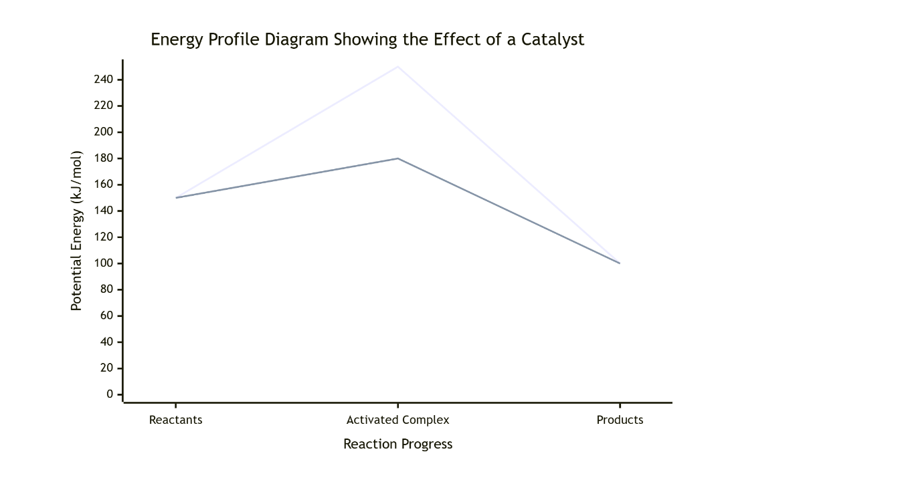
The energy profile diagram for a reaction plots the potential energy of the system against the reaction progress (time). The diagram shows the energy of the reactants, a peak representing the activation energy (Ea) required to form the activated complex, and the energy of the products. For a catalyzed reaction, a second, lower curve is drawn, showing a reduced activation energy (Ea'). The starting and ending points (energy of reactants and products) remain unchanged, indicating the catalyst does not affect the overall enthalpy change (ΔH) of the reaction.
ii. What is the effect of a catalyst on the following?
a) The rate of reaction: A catalyst increases the rate of a chemical reaction. It does this by providing an alternative reaction pathway. This new pathway has a lower activation energy compared to the uncatalyzed pathway. With a lower energy barrier, a greater proportion of the colliding particles possess the necessary energy to react, leading to a higher frequency of effective collisions and a faster rate.
b) The energy of activation: A catalyst lowers the activation energy required for the reaction to occur. It provides a different mechanism for the reaction that involves a lower-energy transition state (activated complex). This lower activation energy is the key reason why the reaction rate increases.
iii. Why does powdered Zn react faster with acid than a piece of Zn? Give reason.
Powdered zinc has a much larger total surface area compared to a solid piece of zinc of the same mass. A larger surface area means more zinc atoms are exposed and available for collision with the H⁺ ions from the acid. According to collision theory, this increased surface area leads to a higher frequency of collisions between the reactant particles. Consequently, the number of effective collisions per unit time increases, resulting in a faster reaction rate and quicker production of hydrogen gas.
iv. List physical parameters which are affected by reaction rates.
Several physical parameters change as a reaction proceeds and its rate can be monitored by measuring these changes. Key parameters include:
- Change in Mass: In an open system, if a gas is produced, the mass of the reaction mixture decreases as the gas escapes.
- Formation of Gas: The volume or pressure of gas produced can be measured over time.
- Change in Temperature: Exothermic or endothermic reactions cause a temperature change in the surroundings.
- Change in Color: The intensity of colour of a reactant or product can be monitored as the reaction proceeds.
- Change in Concentration: The concentration of a reactant or product can be measured directly using various techniques.
v. Explain collision theory and its key components.
Collision theory states that for a chemical reaction to occur, reactant particles must collide with each other. However, not all collisions are successful. For a collision to result in a reaction, two key conditions must be met simultaneously:
- Sufficient Energy: The colliding particles must possess kinetic energy equal to or greater than the activation energy (Ea) of the reaction. This energy is needed to break the existing bonds in the reactants.
- Correct Orientation: The particles must be aligned in a specific geometric way that allows the necessary atoms to come into contact for new bonds to form. An incorrect orientation results in the particles simply bouncing apart without reacting.
vi. Discuss the effect of changing the concentration of a reactant on the rate of reaction.
Increasing the concentration of a reactant means there are more particles of that substance per unit volume. With more particles crowded into the same space, the frequency of collisions between the reactant particles increases. According to collision theory, a higher collision frequency leads directly to a greater number of effective collisions per unit time. Therefore, the rate at which products are formed increases, speeding up the overall reaction. Conversely, decreasing the concentration has the opposite effect, slowing the reaction down.

vii. Describe how graphs are used to interpret the rate of reaction.
Graphs are essential tools for interpreting reaction rates. A common method is to plot the concentration of a reactant or product against time. The rate of reaction at any specific instant is given by the gradient (slope) of the tangent to the curve at that point.
- A steep slope indicates a fast rate (high concentration change in a short time).
- A shallow slope indicates a slow rate.
- The slope typically decreases over time as reactants are used up, showing that the rate slows down. The graph provides a visual representation of how the rate changes throughout the course of the reaction.
viii. Why is activation energy important in determining the rate of reaction?
Activation energy is the minimum energy barrier that must be overcome for reactant particles to be transformed into products. It is crucial because it determines the fraction of colliding particles that possess sufficient energy to react. A high activation energy means that at a given temperature, only a small fraction of collisions will be energetic enough, resulting in a slow reaction. A low activation energy means a larger fraction of collisions are successful, leading to a fast reaction. Therefore, Ea is a key factor controlling the reaction rate.
ix. If you increase the temperature of a reaction, how does this affect the kinetic energy of the particles?
Increasing the temperature of a system directly increases the average kinetic energy of the particles. The particles move faster and more vigorously. This increase in kinetic energy has two important consequences: firstly, it causes particles to collide more frequently. Secondly, and more significantly, it shifts the Maxwell-Boltzmann distribution curve to the right, meaning a much larger proportion of particles now have kinetic energy equal to or greater than the activation energy, leading to a rapid increase in the reaction rate.

x. Why do only a fraction of collisions lead to a reaction according to collision theory?
Only a fraction of collisions lead to a reaction because two strict conditions must be met simultaneously for a collision to be effective. First, the colliding particles must have a combined kinetic energy that meets or exceeds the activation energy barrier. At any given temperature, only a subset of particles have this much energy. Second, the particles must collide with the correct spatial orientation to allow the bonds to break and form in the required way. The probability of a collision satisfying both the energy and orientation criteria is relatively low, hence only a fraction of collisions are successful.
xi. Evaluate how increasing activation energy affects the rate of reaction.
Increasing the activation energy has a profoundly negative effect on the rate of reaction. Activation energy is the minimum energy required for a successful collision. According to the Maxwell-Boltzmann distribution, a higher energy barrier means that a significantly smaller fraction of the reactant particles will possess kinetic energy equal to or greater than this value at a given temperature. This drastic reduction in the proportion of particles with sufficient energy leads to a sharp decrease in the number of effective collisions per unit time. Consequently, the reaction rate becomes very slow. This is why reactions with high activation energies often require a catalyst to lower the barrier and become feasible at reasonable temperatures.
xii. Suggest a way to identify if a catalyst has been effective in a reaction.
The most direct way to identify an effective catalyst is to measure and compare the rate of the reaction in its absence and its presence under otherwise identical conditions (same temperature, concentration, etc.). An effective catalyst will cause a noticeable increase in the reaction rate. This can be quantified by measuring a change in a physical parameter over time, such as:
- The volume of gas produced per unit time (faster gas evolution indicates a faster rate).
- The change in concentration of a reactant or product using a technique like titration or calorimetry (a steeper concentration change indicates a faster rate).
A key follow-up test is to recover the catalyst at the end of the reaction; if it is unchanged in mass and composition, it confirms its role as a catalyst.
xiii. Assess the impact of catalysts on industrial chemical processes.
Catalysts have a transformative impact on industrial chemical processes, primarily by enhancing economic efficiency and sustainability. They allow reactions to proceed rapidly at much lower temperatures and pressures, which drastically reduces the energy consumption and cost of operation. This also improves safety by avoiding extreme conditions. Furthermore, catalysts can increase the atom economy or selectivity of a process, minimizing wasteful by-products and simplifying purification. For example, the Haber process for ammonia synthesis would be economically unviable without an iron catalyst. Overall, catalysts are indispensable for making large-scale chemical manufacturing feasible, cheaper, and greener.
xiv. Evaluate the impact of adding an enzyme to a biochemical reaction.
Adding an enzyme to a biochemical reaction has a dramatic, positive impact by accelerating the rate to a level necessary for life. Enzymes are highly efficient biological catalysts, often increasing reaction rates by a factor of a million or more. Their key impact lies in their specificity; each enzyme typically catalyzes only one specific reaction, ensuring metabolic pathways are regulated with precision. By binding to specific substrates, enzymes lower the activation energy barrier and hold reactants in the optimal orientation for reaction. This allows vital processes like digestion and cellular respiration to occur rapidly at mild physiological temperatures (37°C), where they would otherwise be immeasurably slow.
xv. Analyze how temperature control during transportation can affect the quality of the product.
Temperature control during transportation is a direct application of chemical kinetics that is critical for preserving product quality. The rates of degradation reactions in food and pharmaceuticals, such as microbial growth, enzyme action, and oxidation, are highly temperature-dependent. Lowering the temperature (refrigeration or freezing) significantly reduces the kinetic energy of molecules, thereby slowing down these spoilage reactions. This extends the product's shelf life by delaying spoilage, ripening, and nutrient loss. Conversely, uncontrolled high temperatures accelerate these processes, leading to spoilage, loss of texture, flavor degradation, and reduced nutritional value by the time the product reaches the consumer.

THINK TANK
1. Analyse a scenario where a catalyst is not effective in increasing the rate of reaction.
A catalyst would be ineffective if the reaction it is intended to speed up is already occurring at its maximum possible rate under the given conditions, or if the reaction is thermodynamically impossible. For example, a catalyst cannot make diamond spontaneously form from graphite at room temperature because the reaction is not favored by thermodynamics (it has a very positive Gibbs free energy change, ΔG > 0). Catalysts only affect the kinetics (the speed) of a reaction, not its thermodynamics (whether it can happen at all). Additionally, a catalyst might be ineffective if it is poisoned by impurities that block its active sites, or if the conditions (e.g., pH for an enzyme) are outside its functional range, causing it to denature or become inactive.
2. Evaluate the role of chemical kinetics in optimizing food production processes in the food industry.
Chemical kinetics is fundamental to optimizing food production, from processing to packaging. It allows scientists to:
- Determine Shelf Life: By studying the rates of degradation reactions (like lipid oxidation or microbial growth), kinetics helps predict how long a product will remain safe and high-quality.
- Optimize Processing Conditions: Kinetics helps find the ideal time and temperature for processes like pasteurization (to kill pathogens without overcooking) or baking (to achieve the right texture without burning).
- Design Effective Packaging: Understanding reaction rates leads to packaging solutions like Modified Atmosphere Packaging (MAP), which slows down spoilage by controlling the rates of oxidative reactions.
- Preserve Nutrients: Kinetics guides the design of processes that minimize the destruction of heat-sensitive vitamins, ensuring the nutritional value of the final product.
3. Predict the effect of doubling the surface area of a solid reactant on the rate of reaction, providing reasoning based on collision theory.
Based on collision theory, doubling the surface area of a solid reactant will approximately double the rate of the reaction, provided all other conditions (temperature, concentration of the other reactant) remain constant. The reasoning is that the surface area of the solid is directly proportional to the number of its particles exposed and available for collision. Doubling the surface area effectively doubles the number of sites where collisions with particles from the other reactant (e.g., H⁺ ions in acid) can occur. This leads to a direct doubling of the collision frequency. According to collision theory, an increase in collision frequency results in a proportional increase in the number of effective collisions per second, thereby doubling the reaction rate.
4. Explain why the formation of a gas is often associated with an increase in the rate of reaction.
The formation of a gas is often a result of a fast reaction rather than a cause of an increased rate. However, it can sometimes contribute to an apparent increase in rate, especially in heterogeneous reactions. For example, in the reaction between zinc and acid, the vigorous bubbling of hydrogen gas stirs the reaction mixture. This agitation brings fresh acid into contact with the metal surface more efficiently, preventing a stagnant layer of depleted acid from forming around the metal. This mixing effect increases the frequency of collisions between reactants, which can help maintain a high reaction rate. Therefore, the gas evolution can create a feedback loop that enhances mixing and supports a faster observed rate.

